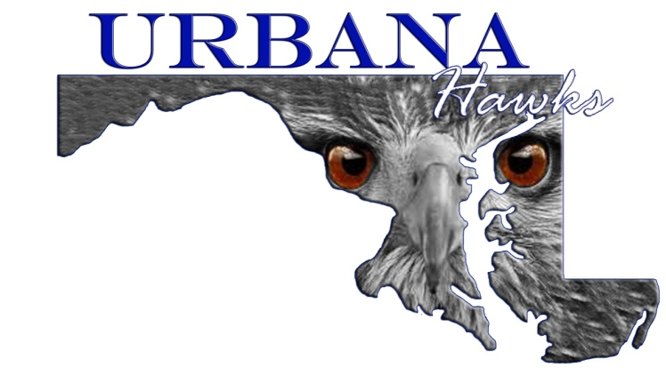

Urbana Youth Football Cheer and Pom

PARENTS CODE OF CONDUCT
- I hereby pledge to provide positive support, care, and encouragement for my child participating in youth sports by following this code of ethics.
- I will encourage good sportsmanship by demonstrating positive support for all players, coaches, and officials at every game, practice, or other youth sports events.
- I will place the emotional and physical well-being of my child ahead of any personal desire to win.
- I will insist that my child play in a safe and healthy environment.
- I will provide support for coaches and officials working with my child to provide a positive, enjoyable experience for all.
- I will demand a drug, alcohol, and tobacco-free sports environment for my child and agree to assist by refraining from their use at all youth sports events.
- I will remember that the game is for children and not for adults.
- I will do my very best to make youth sports fun for my child.
- I will ask my child to treat other players, coaches, fans, and officials with respect regardless of race, sex, creed, or ability.
- I will always address any issues with my child’s coach in private.
- I will promise to help my child enjoy the youth sports experience within my personal constraints by assisting with coaching, being a respectful fan, providing transportation or whatever I am capable of doing.

____________________________
Players Name

____________________________ __________________________
Parent Name Print Parents Name Print

____________________________ __________________________
Parent Name Signature Parents Name Signature

