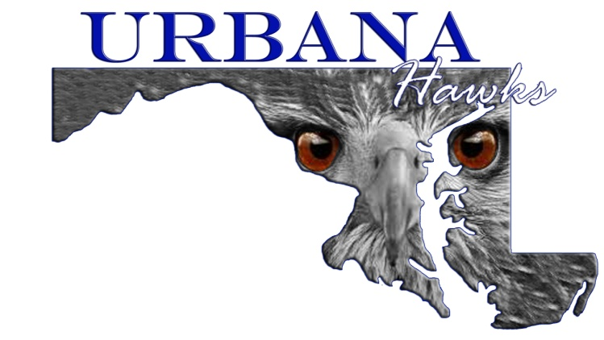

Urbana Youth Football, Cheer, and Pom
(Football)

COACHES CODE OF CONDUCT
- Uphold all rules and regulations of the Mountain Valley Youth Football League, (MVYFL).
- Assure that each coach and team official has access to and has read all league regulations.
- Assure that each player knows and obeys the Players Code of Conduct.
- Any coach or team official that knowingly allows an ineligible player to participate in a game will be subject to disciplinary action by the Executive Board.
- It is deemed proper ethics that anyone that knows in advance or has strong suspicions of an ineligible player should contact any executive member of the Urbana Youth Football, Cheer and Pom Committee (UYFCP) and the Football Commissioner as soon as possible.
- Accept decisions of the game officials on the field as being fair and called to the best ability of said officials.
- Together with game officials, be jointly responsible for the conduct and control of team fans and spectators. Any fan that becomes a nuisance and is out of control is the responsibility of the coach and should be removed from the area.
- Do not leave the coach’s area to shout instructions from sidelines.
- Do not criticize players in front of spectators, with gestures and loud noises, but reserve criticism until a more private opportunity arises.
- Do not criticize an opposing team, its players, coaches or fans, by words or by gestures.
- Refrain from using abusive and profane language to anyone connected with the game, as a spectator, player, opposing coach or game official.
- Do not deliberately incite unsportsmanlike conduct. An instruction to players to “get” another player or attempt to impose bodily harm to opposing players is considered incitement.
- Abstain from drinking of alcoholic beverages and smoking on both game and practice fields.
- Avoid running up scores. Abide by all rules of the Mountain Valley Youth Football League and use common sense.
- Assure that no player practices or plays in a game without proper equipment.
- Remove from a game or practice, any player when slightly in doubt about his health, whether or not a result of injury, until competent medical advice is available.
- Assure that a player’s scholastic achievement does not suffer because of participation in Mountain Valley Youth Football League.
- Any coach who actively solicits a player from another organization by either making telephone calls, sending emails or personal visits will be penalized.

Full Name (Please Print)

Signature Date

